**Top 5 Places to visit in London**

**We have picked 5 gems from the sea of riches that is London. These places are so mesmerising you won’t be able to resist the temptation.**

**5. The Buckingham palace**

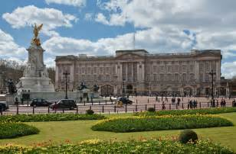 **£17**

**The Buckingham palace is a historical beauty. You can have the opportunity to visit the place that has housed many royal members. It can only be visited during the summer as it is used for royal affairs during the other seasons. It would be wise to book a ticket before summer begins in the year as it is such a popular tourist attraction.**

**Google Maps:**

<https://www.google.co.uk/maps/place/Buckingham+Palace/@51.501364,-0.1440787,17z/data=!3m1!4b1!4m5!3m4!1s0x48760520cd5b5eb5:0xa26abf514d902a7!8m2!3d51.501364!4d-0.14189>

**4.The London Eye – £23**

**The London eye is one of the most iconic attractions in London. Admire all the landmarks and buildings in London from a towering 135m.**

**3.** [**Warner Bros. Studio Tour London – The Making of Harry Potter**](http://www.visitlondon.com/things-to-do/place/23035130)

**£69**

**On the behalf of Professor Dumbledore, I invite you all to Hogwarts school of witchcraft and wizardry. This is the perfect destination for those who went on the magical journey with Harry and his friends in all the Harry potter films. On the tour, you will have the opportunity to see the sets, props and costumes used to create the most successful film series of all time.**

**2. Sea Life**

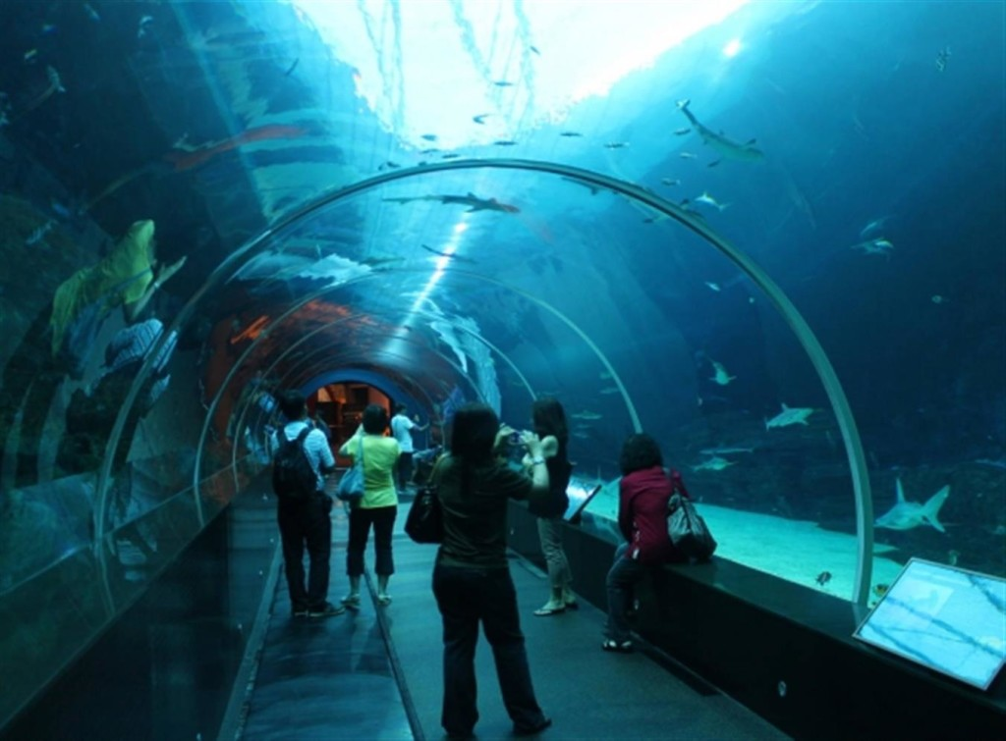

**£20**

**Why dive 100 of feet into the ocean when Sea Life can bring the ocean to you. See all the strange and wonderful aquatic animals of the ocean, without risk your life at Sea life.**

**1.The Shard-£25**

**If you’re a frill seeker then The Shard is the place to be. Visit the tallest building, not only in London, but the tallest building in the whole of western Europe.The Shard is the best place to admire how magnificent and unique London is.**

**Google Maps:**

<https://www.google.co.uk/maps/place/The+Shard/@51.5045033,-0.0886887,17z/data=!3m1!4b1!4m5!3m4!1s0x4876035a0a9271d3:0xbdf26ba73efb7b!8m2!3d51.5045!4d-0.0865>